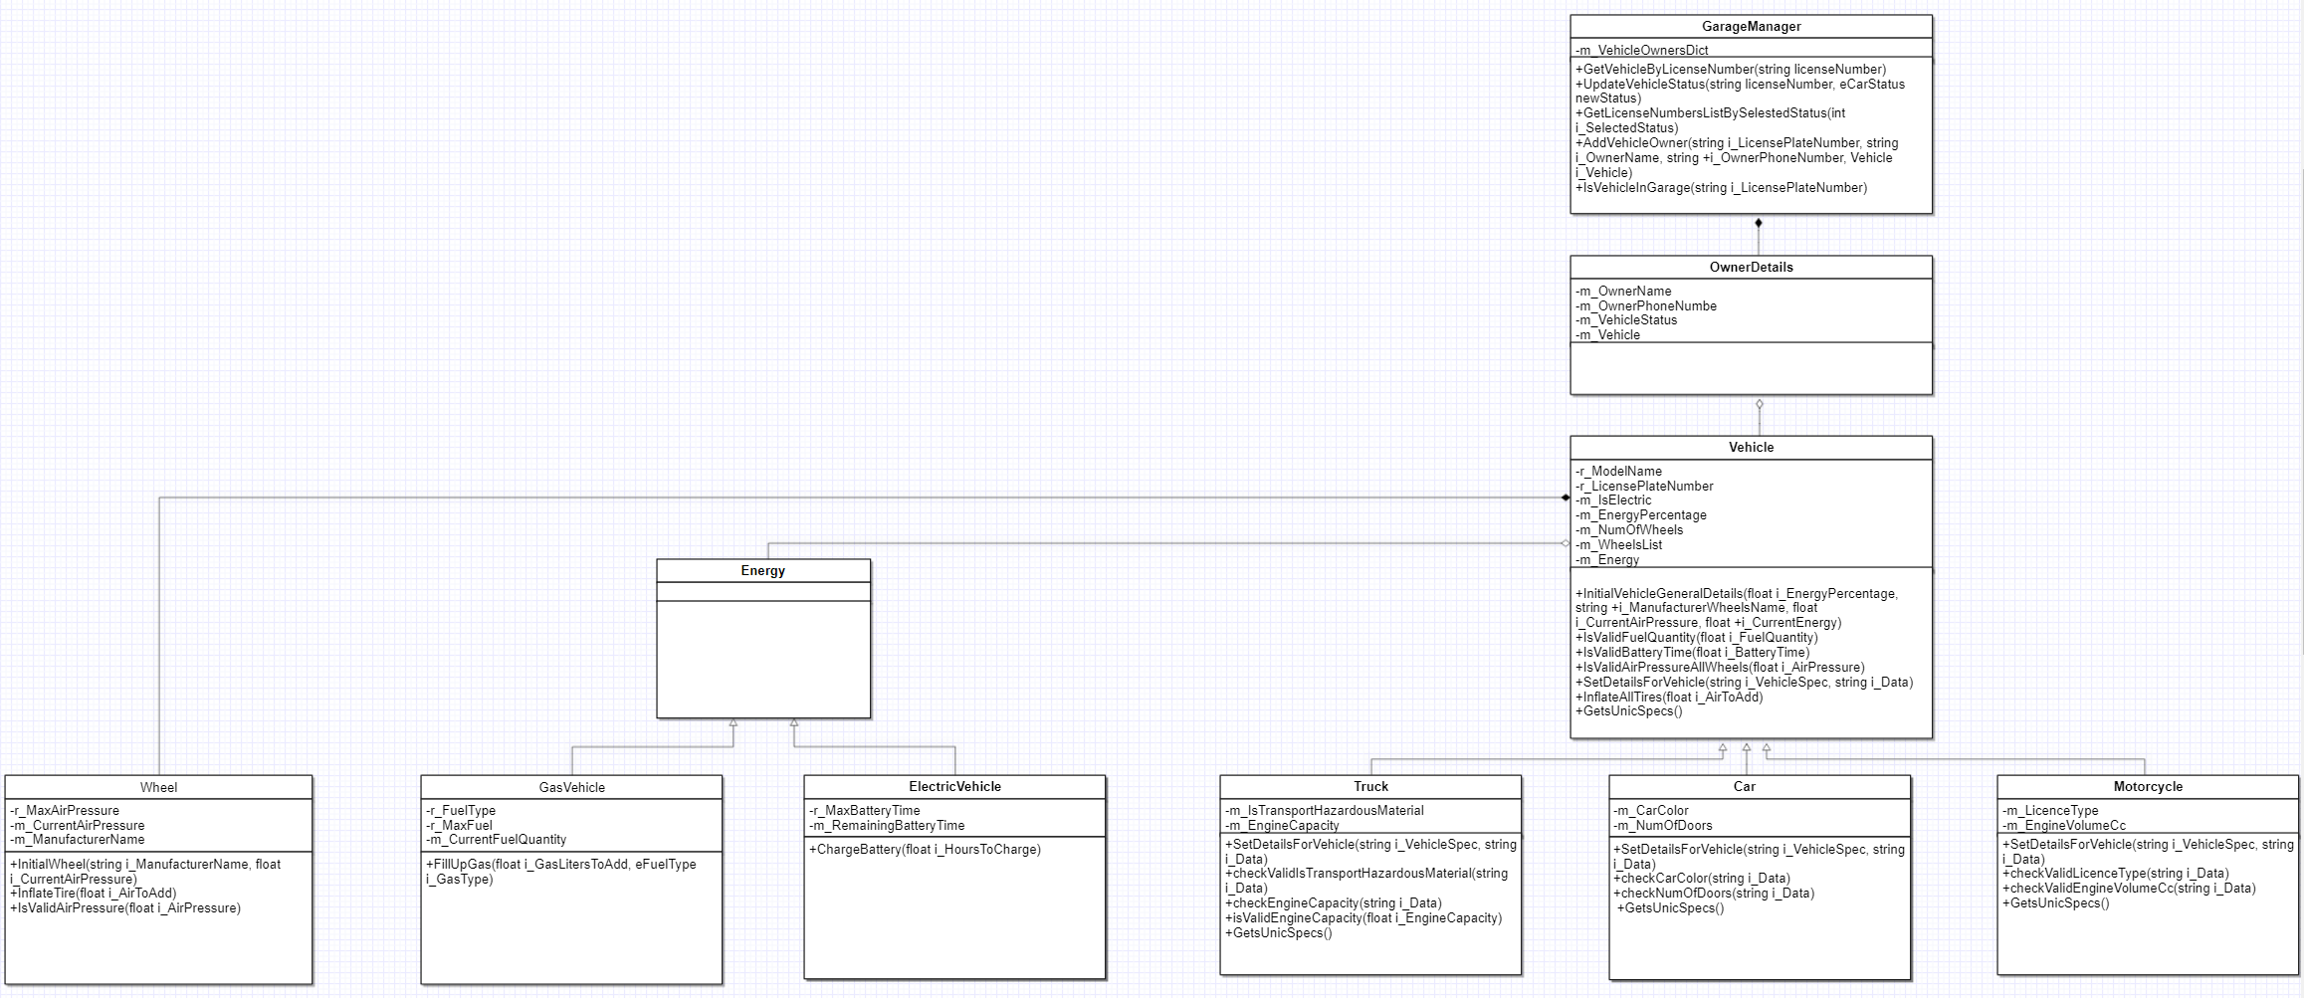
GarageManager – holds a dictionary of where the key is the license plate and the value is OwnerDetails, and does basic stuff like checking if the vehicle is in the garage and adding a new vehicle.
OwnerDetails - holds an object of type Vehicle, the purpose of this variable is to hold a reference to the associated vehicle owned by the owner.
Vehicle – holds an object that represents a single wheel of a vehicle. It is used in the Vehicle class to manage the wheels of a vehicle, and an object of type Energy which is an abstract class, which is used to determine if the vehicle is electric or fuel based.
Car, Truck, Motorcycle – all these classes are derived classes of the Vehicle class. They represent a type of a vehicle which have additional properties and behavior specific to their type.
Energy, GasVehicle/ElectricVehicle – The energy is an abstract class, while the other 2 classes inherit from him. These 2 classes provide a foundation for managing different types of energy sources in the garage system. The ElectricVehicle class handles electric vehicle-specific operations such as charging the battery, while the GasVehicle class manages gas vehicle-specific operations such as refueling the tank.
Wheel - is responsible for managing individual wheels in the context of Vehicle, the Wheel class provides functionality to manage the air pressure of a wheel, such as inflating the tire and validating air pressure values.

